- Explain Exploratory Data Analysis (EDA). Why is EDA important?
Exploratory Data Analysis (EDA) is the process of investigating a dataset to understand its main characteristics, discover patterns, detect anomalies, test hypotheses, and check assumptions — all before applying formal modeling or machine learning techniques. It’s like taking your dataset out for coffee to see what it’s really like before you commit to building a full-blown predictive model.
EDA is a philosophy and a set of techniques used to explore and summarize datasets before more formal modeling or hypothesis testing. Key aspects of EDA include:
- Summarizing Data Characteristics: It helps describe the main features of a dataset.
- Visualizing Data: Using charts and graphs to identify patterns, relationships, and outliers is a common and effective approach.
- Identifying Errors and Anomalies: EDA helps detect obvious errors, missing values, and unusual data points (outliers) that could skew analysis.
- Formulating Hypotheses: It helps develop initial hypotheses and ideas that can be tested later.
- Understanding Variables: It allows for the identification of important variables and their relationships.

Why is EDA important?
- Understand the data structure – size, types of variables, missing values.
- Detect outliers or anomalies – spot data points that don’t fit expectations.
- Validate assumptions : check if data meets conditions required for statistical models.
- Guide feature engineering : identify what transformations or new variables might help.
- Prevent costly mistakes : ensures you don’t feed bad data into your model.
- Enhances Subsequent Analysis: A thorough EDA provides a solid foundation for building more accurate models and performing more sophisticated data analysis.
- Reduces Costs and Time: By identifying issues early, EDA can prevent wasted time and resources on flawed models or incorrect conclusions.
- Explain Key Terms for Data Types
Numeric: Data that are expressed on a numeric scale.
Continuous: Data that can take on any value in an interval. (Synonyms: interval, float,numeric)
Discrete: Data that can take on only integer values, such as counts. (Synonyms: integer,count)
Categorical: Data that can take on only a specific set of values representing a set of possible categories. (Synonyms: enums, enumerated, factors, nominal)
Binary: A special case of categorical data with just two categories of values, e.g., 0/1, true/false. (Synonyms: dichotomous, logical, indicator, boolean)
Ordinal: Categorical data that has an explicit ordering. (Synonym: ordered factor)
Categorical and ordinal data are important in analytics, even though they may appear to be just collections of text or numbers. Explicitly identifying data as categorical provides several advantages:
- Guidance for statistical procedures – Software can use data typing to determine how to handle operations like charting, tabulation, or modeling. For example, R uses ordered.factor to preserve order in charts and models, while scikit-learn in Python supports ordinal encoding.
- Storage and indexing optimization – Relational databases can store and index categorical values more efficiently.
- Enforcement of valid values – Categorical typing restricts a variable to predefined categories (similar to enums).
However, this enforcement can cause issues. For instance, in R, text columns imported with read.csv are converted to factors by default, which may lead to warnings or missing values when new categories are introduced. In contrast, Python’s pandas does not convert text to categorical automatically but allows explicit specification.
Key ideas: Data is classified by type (numeric: continuous/discrete; categorical: binary/ordinal). Declaring types helps software decide how to process and analyze data correctly.
- Explain Estimates of Location. Find the mean, median , SD, Trimmed Mean for the Data set =[10 15 20 25 30 35 40 45 50 ]. Write python code for Mean, median, SD.
Estimates of Location
Variables with measured or count data might have thousands of distinct values. A basic step in exploring your data is getting a “typical value” for each feature (variable): an estimate of where most of the data is located (i.e., its central tendency).
Mean: The sum of all values divided by the number of values.
Synonym -Average
Weighted mean: The sum of all values times a weight divided by the sum of the weights.
Synonym-weighted average
Median: The value such that one-half of the data lies above and below.
Synonym-50th percentile
Percentile: The value such that P percent of the data lies below.
Synonym-Quantile
Weighted median: The value such that one-half of the sum of the weights lies above and below the sorted data.
Trimmed mean: The average of all values after dropping a fixed number of extreme values.
Synonym - truncated mean
Robust: Not sensitive to extreme values.
Synonym-resistant
Outlier: A data value that is very different from most of the data.
Synonym- extreme value
Python code:
import numpy as np
from scipy import stats
data = [10, 15, 20, 25, 30, 35, 40, 45, 50]
# Mean
mean_val = np.mean(data)
# Median
median_val = np.median(data)
# Standard Deviation
sd_val = np.std(data)
# Trimmed Mean (10% trim)
trimmed_mean_val = stats.trim_mean(data, 0.1)
print("Mean:", mean_val)
print("Median:", median_val)
print("Standard Deviation:", sd_val)
print("Trimmed Mean (10%):", trimmed_mean_val)

- Define key terms in Exploring the Data Distribution.
Each of the estimates we’ve covered sums up the data in a single number to describe the location or variability of the data. It is also useful to explore how the data is dis‐ tributed overall.
Key terms
Boxplot: A plot introduced by Tukey as a quick way to visualize the distribution of data.
Summarizes the data using quartiles:
Q1 (25th percentile)
Median (50th percentile)
Q3 (75th percentile)
Whiskers show minimum and maximum (or near-min/max), and any outliers.
Frequency table: Shows how many observations fall in each class interval.
Histogram: A bar graph showing the same frequencies visually. Taller bars = higher frequencies. It’s essentially the graphical form of your frequency table.
Density plot: A smoothed version of the histogram, often based on a kernel density estimate. instead of bars, it shows a continuous curve
- What is percentile and IQR .write the python code for percentile and IQR w.r.t population as an example?
Percentile: The value such that P percent of the values take on this value or less and (100–P) percent take on this value or more.
- For example, the 25th percentile (P25) is the value below which 25% of the data lies.
- Similarly, the 90th percentile (P90) means 90% of the data is below that value.
Percentiles help in understanding the distribution of data and detecting outliers.
Synonym-quantile
Interquartile range: The difference between the 75th percentile and the 25th percentile. Synonym- IQR
IQR=Q3−Q1
It measures the spread of the middle 50% of data, making it robust to outliers.
import numpy as np
# Example population dataset (exam scores of 15 students)
population = [55, 60, 65, 70, 72, 75, 78, 80, 82, 85, 88, 90, 92, 95, 98]
# Percentiles
p25 = np.percentile(population, 25) # Q1
p50 = np.percentile(population, 50) # Median
p75 = np.percentile(population, 75) # Q3
p90 = np.percentile(population, 90) # 90th Percentile
# Interquartile Range (IQR)
iqr = p75 - p25
print("25th Percentile (Q1):", p25)
print("50th Percentile (Median):", p50)
print("75th Percentile (Q3):", p75)
print("90th Percentile:", p90)
print("Interquartile Range (IQR):", iqr)
- What are Density Plots and Estimates. explain with figure and python code for 1,00,000(murder rate)
Density Plots
A density plot is closely related to a histogram, but instead of using bars to represent frequencies, it displays the distribution of data values as a smooth continuous line. You can think of it as a smoothed histogram that shows how data is distributed across values without depending on the size of bins.
The smoothness of the curve is achieved using a statistical method called Kernel Density Estimation (KDE). KDE uses the data points directly to estimate a probability density function. Unlike histograms that may change shape depending on how many bins you choose, density plots give a more stable picture of the underlying distribution.
A key distinction between histograms and density plots lies in the y-axis scale:
- Histograms show frequency counts (or normalized frequencies if specified).
- Density plots show probability density, where the area under the curve equals 1.
Instead of counting how many observations fall in bins, density plots allow us to interpret the area under the curve between two values as the proportion of the distribution within that range.

Density Estimation
Density estimation is a well-studied topic in statistics, with multiple approaches and refinements. For instance, in R, over 20 packages exist for density estimation, such as ASH and KernSmooth, recommended by [Deng-Wickham-2011]. In Python, both pandas and scikit-learn provide robust implementations of KDE.
For many practical data science tasks, the base functions in R or pandas are sufficient. Advanced methods are useful mainly when the underlying distribution is highly irregular or when more precise smoothing is required.
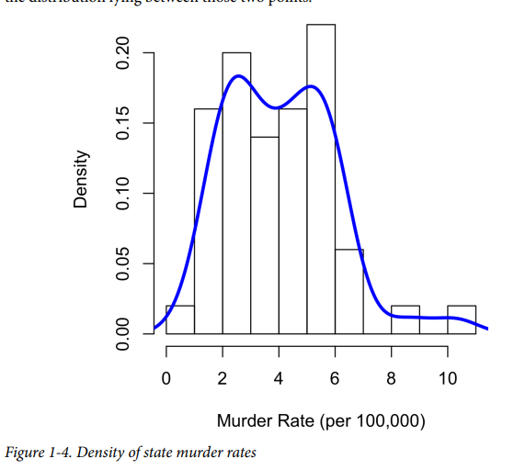
import numpy as np
import pandas as pd
import matplotlib.pyplot as plt
import seaborn as sns
# Simulated murder rate dataset (per 100,000 people)
np.random.seed(42)
murder_rate = np.random.normal(loc=5, scale=2, size=100000) # mean=5, std=2

# Create histogram + density overlay
plt.figure(figsize=(10,6))
sns.histplot(murder_rate, bins=30, kde=False, stat="density", color="skyblue", label="Histogram")
sns.kdeplot(murder_rate, color="red", linewidth=2, label="Density Plot")
plt.title("Histogram with Density Plot of Murder Rate (per 100,000)", fontsize=14)
plt.xlabel("Murder Rate per 100,000 People")
plt.ylabel("Density (Proportion)")
plt.legend()
plt.show()
- What is Correlation and Scatterplot .find the correlated value for v1: {1, 2, 3} v2: {4, 5, 6}
Correlation
Exploratory data analysis in many modeling projects (whether in data science or in research) involves examining correlation among predictors, and between predictors and a target variable. Variables X and Y (each with measured data) are said to be positively correlated if high values of X go with high values of Y, and low values of X go with low values of Y. If high values of X go with low values of Y, and vice versa, the variables are negatively correlated.
Key terms
Correlation coefficient: A metric that measures the extent to which numeric variables are associated with one another (ranges from –1 to +1).
Correlation matrix: A table where the variables are shown on both rows and columns, and the cell values are the correlations between the variables.
Scatterplot: A plot in which the x-axis is the value of one variable, and the y-axis the value of
another.
Consider these two variables, perfectly correlated in the sense that each goes from low
to high:
v1: {1, 2, 3}
v2: {4, 5, 6}
The vector sum of products is 1 ・ 4 + 2 ・ 5 + 3 ・ 6 = 32.
Scatterplots
The standard way to visualize the relationship between two measured data variables is with a scatterplot. The x-axis represents one variable and the y-axis another, and each point on the graph is a record. See Figure 1-7 for a plot of the correlation between the daily returns for ATT and Verizon.
The same graph can be generated in Python using the pandas scatter method:
ax = telecom.plot.scatter(x='T', y='VZ', figsize=(4, 4), marker='$\u25EF$')
ax.set_xlabel('ATT (T)')
ax.set_ylabel('Verizon (VZ)')
ax.axhline(0, color='grey', lw=1)
ax.axvline(0, color='grey', lw=1)
The returns have a positive relationship: while they cluster around zero, on most days, the stocks go up or go down in tandem (upper-right and lower-left quadrants).
There are fewer days where one stock goes down significantly while the other stock goes up, or vice versa (lower-right and upper-left quadrants).
While the plot Figure 1-7 displays only 754 data points, it’s already obvious how difficulit is to identify details in the middle of the plot. We will see later how adding transparency to the points, or using hexagonal binning and density plots, can help to find additional structure in the data.
- Define hexagonal binning with Python code .write python code for taxassessed value versus finished square feet
•Hexagonal binning is a data visualization technique used when you have a large number of scatterplot points, which can cause overplotting (points overlap so much that patterns are hidden).
• Instead of plotting each point individually, the 2D space is divided into hexagonal bins. Each bin counts how many points fall inside it, and the counts are then represented with color intensity.
• It’s especially useful for visualizing relationships between two continuous variables with dense datasets (like housing datasets).
Scatterplots are fine when there is a relatively small number of data values. The plot
of stock returns in Figure 1-7 involves only about 750 points. For data sets with hundreds of thousands or millions of records, a scatterplot will be too dense, so we need a different way to visualize the relationship. To illustrate, consider the data set kc_tax, which contains the tax-assessed values for residential properties in King County, Washington. In order to focus on the main part of the data, we strip out very expensive and very small or large residences using the subset function:
Figure 1-8. Hexagonal binning for tax-assessed value versus finished square feet
hexagonal binning plot of the relationship between the finished square feet and the tax-assessed value for homes in King County. Rather than plotting points, which would appear as a monolithic dark cloud, we grouped the records into hexagonal bins and plotted the hexagons with a color indicating the number of records in that bin. In this chart, the positive relationship between square feet and tax-assessed value is clear. An interesting feature is the hint of additional bands above the main (darkest) band at the bottom, indicating homes that have the same square footage as those in the main band but a higher tax-assessed value.
In Python, hexagonal binning plots are readily available using the pandas data frame
method hexbin:
ax = kc_tax0.plot.hexbin(x='SqFtTotLiving', y='TaxAssessedValue',
gridsize=30, sharex=False, figsize=(5, 4))
ax.set_xlabel('Finished Square Feet')
ax.set_ylabel('Tax-Assessed Value')
Module 2

1. What is sampling w.r.t population? Explain Random Sampling and Sample Bias.
The Sampling is a statistical process of selecting few representatives from the population, called as a sample, on the basis of which the characteristics of the total population can be ascertained
Random Sampling and Sample Bias
A sample is a subset of data from a larger data set; statisticians call this larger data set the population. A population in statistics is not the same thing as in biology—it is a large, defined (but sometimes theoretical or imaginary) set of data.
Random sampling is a process in which each available member of the population being sampled has an equal chance of being chosen for the sample at each draw. The sample that results is called a simple random sample. Sampling can be done with replacement, in which observations are put back in the population after each draw for possible future reselection. Or it can be done without replacement, in which case observations, once selected, are unavailable for future draws.
Data quality often matters more than data quantity when making an estimate or a model based on a sample. Data quality in data science involves completeness, consistency of format, cleanliness, and accuracy of individual data points. Statistics adds the notion of representativeness.
Sample bias (also called sampling bias) happens when the sample you collect for a study, survey, or dataset is not truly representative of the entire population you’re trying to analyze.
Because of this, the results you get may be skewed or misleading, since some groups are overrepresented or underrepresented.
Simple Random Sampling
Definition: The Simple Random Sampling is a sampling technique wherein every item of the population has an equal and likely chance of being selected in the sample. Here, the selection of the item solely depends on the chance and therefore, this method is also called as a Method of Chance Selection.
2. Define Key Terms for Random Sampling.
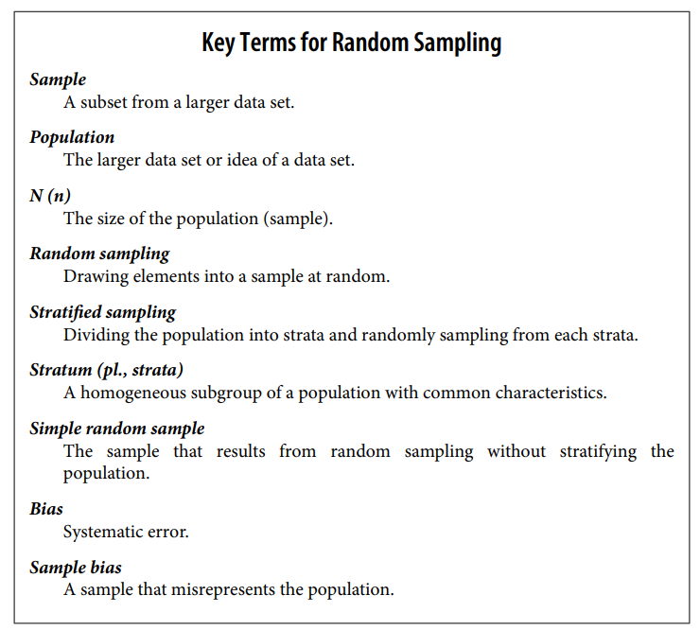
or
• Sample
A subset of a larger dataset (population) selected for analysis.
• Population
The entire dataset or group that you want to study or draw conclusions about.
• N (Population size), n (Sample size)
- N = total number of elements in the population.
- n = number of elements in the sample.
• Random Sampling
A method where elements are drawn into a sample purely by chance, so each member of the population has an equal probability of being selected.
• Stratified Sampling
A method where the population is divided into homogeneous subgroups (strata) based on shared characteristics (e.g., age, income level), and then random samples are taken from each stratum.
• Stratum (plural: Strata)
A subgroup of a population with common characteristics used in stratified sampling.
• Simple Random Sample
A sample created by random sampling without dividing the population into strata. Every element has an equal chance of selection.
• Bias
A systematic error that skews results away from the truth.
• Sample Bias
A type of bias where the sample does not accurately represent the population, leading to misleading or incorrect conclusions.
Explain bias w.r.t Scatterplot of shots from a gun with true aim & Scatterplot of shots from a gun with biased aim
Bias w.r.t scatterplot
Statistical bias refers to measurement or sampling errors that are systematic and produced by the measurement or sampling process. An important distinction should be made between errors due to random chance and errors due to bias. Consider the physical process of a gun shooting at a target. It will not hit the absolute center of the target every time, or even much at all. An unbiased process will produce error, but it is random and does not tend strongly in any direction (see Figure 2-2). The results shown in Figure 2-3 show a biased process—there is still random error in both the x and y direction, but there is also a bias. Shots tend to fall in the upper-right quadrant
Bias comes in different forms, and may be observable or invisible. When a result does suggest bias (e.g., by reference to a benchmark or actual values), it is often an indicator that a statistical or machine learning model has been misspecified, or an important variable left out.
Random sampling is not always easy. Proper definition of an accessible population is key. Suppose we want to generate a representative profile of customers and we need to conduct a pilot customer survey. The survey needs to be representative but is labor intensive.

2-2 Scatterplot of shots from a gun with true aim
2-3 Scatterplot of shots from a gun with biased aim
Explain Regression to the Mean. Draw a plot of Galton’s study that identified the phenomenon of regression to the mean.
Regression to the mean refers to a phenomenon involving successive measurements on a given variable: extreme observations tend to be followed by more central ones.
Attaching special focus and meaning to the extreme value can lead to a form of selection bias.
Sports fans are familiar with the “rookie of the year, sophomore slump” phenomenon.
Among the athletes who begin their career in a given season (the rookie class), there is always one who performs better than all the rest. Generally, this “rookie of the year” does not do as well in his second year. Why not?
In nearly all major sports, at least those played with a ball or puck, there are two elements that play a role in overall performance:
• Skill
• Luck
Regression to the mean is a consequence of a particular form of selection bias. When we select the rookie with the best performance, skill and good luck are probably contributing.
Regression to the mean is a consequence of a particular form of selection bias. When we select the rookie with the best performance, skill and good luck are probably contributing.
In his next season, the skill will still be there, but very often the luck will not be, so his performance will decline—it will regress. The phenomenon was first identified by Francis Galton in 1886 [Galton-1886], who wrote of it in connection with genetic tendencies; for example, the children of extremely tall men tend not to be as tall as their father
Galton’s study that identified the phenomenon of regression to the mean

Define keyterms of Sampling Distribution of a Statistic
The term sampling distribution of a statistic refers to the distribution of some sample statistic over many samples drawn from the same population. Much of classical statis‐ tics is concerned with making inferences from (small) samples to (very large) popula‐ tions.
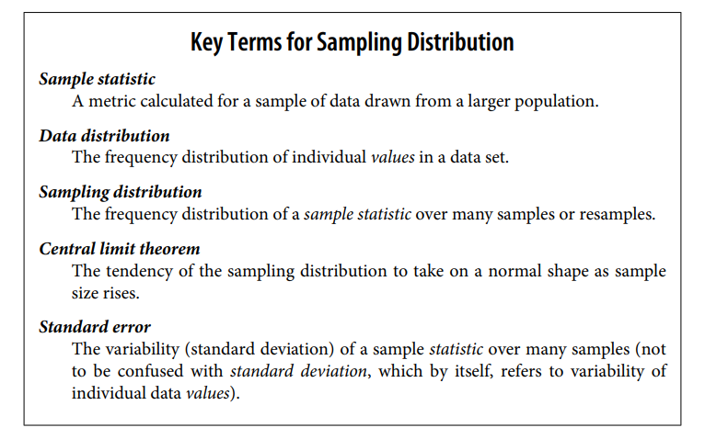
Draw Histogram of annual incomes of 1,000 loan applicants ,Mean 5 and Mean 20 . python code uses seaborn’s FacetGrid to show the three histograms .
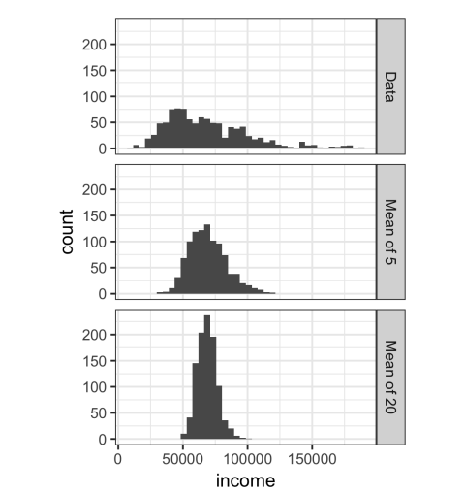
Figure 2-6. Histogram of annual incomes of 1,000 loan applicants (top), then 1,000 means of n=5 applicants (middle), and finally 1,000 means of n=20 applicants (bottom)
The Python code uses seaborn’s FacetGrid to show the three histograms:
import pandas as pd
import seaborn as sns
sample_data = pd.DataFrame({
'income': loans_income.sample(1000),
'type': 'Data',
})
sample_mean_05 = pd.DataFrame({
'income': [loans_income.sample(5).mean() for _ in range(1000)],
'type': 'Mean of 5',
})
sample_mean_20 = pd.DataFrame({
'income': [loans_income.sample(20).mean() for _ in range(1000)],
'type': 'Mean of 20',
})
results = pd.concat([sample_data, sample_mean_05, sample_mean_20])
g = sns.FacetGrid(results, col='type', col_wrap=1, height=2, aspect=2)
g.map(plt.hist, 'income', range=[0, 200000], bins=40)
g.set_axis_labels('Income', 'Count')
g.set_titles('{col_name}')
Explain Central Limit Theorem and S.E .Find S.E for Data set =[10 15 20 25 30 35 40 45 50 ]
Central Limit Theorem
The phenomenon we’ve just described is termed the central limit theorem. It says that the means drawn from multiple samples will resemble the familiar bell-shaped normal curve . even if the source population is not normally distributed, provided that the sample size is large enough and the departure of the data from normality is not too great. The central limit theorem allows normal-approximation formulas like the t-distribution to be used in calculating sampling distributions for inference—that is, confidence intervals and hypothesis tests.
The central limit theorem receives a lot of attention in traditional statistics texts because it underlies the machinery of hypothesis tests and confidence intervals, which themselves consume half the space in such texts. Data scientists should be aware of this role; however, since formal hypothesis tests and confidence intervals play a small role in data science, and the bootstrap (see “The Bootstrap”) is available in any case, the central limit theorem is not so central in the practice of data science.
Standard Error
The standard error is a single metric that sums up the variability in the sampling distribution for a statistic. The standard error can be estimated using a statistic based on the standard deviation s of the sample values, and the sample size n:
Standard error = SE = s/(n)^1/2
As the sample size increases, the standard error decreases, corresponding to what wasobserved in Figure 2-6. The relationship between standard error and sample size is sometimes referred to as the square root of n rule: to reduce the standard error by a factor of 2, the sample size must be increased by a factor of 4.
The validity of the standard error formula arises from the central limit theorem. In fact, you don’t need to rely on the central limit theorem to understand standard error.
Consider the following approach to measuring standard error:
- Collect a number of brand-new samples from the population
2. For each new sample, calculate the statistic (e.g., mean).
3. Calculate the standard deviation of the statistics computed in step 2; use this as your estimate of standard error.
What is Bootstrap. Write the major Python packages don’t provide implementations of the bootstrap approach
The Bootstrap
One easy and effective way to estimate the sampling distribution of a statistic, or of model parameters, is to draw additional samples, with replacement, from the sample itself and recalculate the statistic or model for each resample. This procedure is called the bootstrap, and it does not necessarily involve any assumptions about the data or the sample statistic being normally distributed.
Bootstrap sample
A sample taken with replacement from an observed data set.
Resampling
The process of taking repeated samples from observed data; includes both bootstrap and permutation (shuffling) procedures.
In practice, it is not necessary to actually replicate the sample a huge number of times. We simply replace each observation after each draw; that is, we sample with replacement. In this way we effectively create an infinite population in which the probability of an element being drawn remains unchanged from draw to draw. The
algorithm for a bootstrap resampling of the mean, for a sample of size n, is as follows:
1. Draw a sample value, record it, and then replace it.
2. Repeat n times.
3. Record the mean of the n resampled values.
4. Repeat steps 1–3 R times.
5. Use the R results to:
The major Python packages don’t provide implementations of the bootstrap approach. It can be implemented using the scikit-learn method resample:
results = []
for nrepeat in range(1000):
sample = resample(loans_income)
results.append(sample.median())
results = pd.Series(results)
print('Bootstrap Statistics:')
print(f'original: {loans_income.median()}')
print(f'bias: {results.mean() - loans_income.median()}')
print(f'std. error: {results.std()}’)

Explain Key Terms for Binomial Distribution.
Binomial Distribution
Yes/no (binomial) outcomes lie at the heart of analytics since they are often the culmination of a decision or other process; buy/don’t buy, click/don’t click, survive/die, and so on. Central to understanding the binomial distribution is the idea of a set of trials, each trial having two possible outcomes with definite probabilities.
For example, flipping a coin 10 times is a binomial experiment with 10 trials, each trial having two possible outcomes (heads or tails); see Figure 2-14. Such yes/no or 0/1 outcomes are termed binary outcomes, and they need not have 50/50 probabilities.
Any probabilities that sum to 1.0 are possible. It is conventional in statistics to term the “1” outcome the success outcome; it is also common practice to assign “1” to the more rare outcome. Use of the term success does not imply that the outcome is desirable or beneficial, but it does tend to indicate the outcome of interest. For example, loan defaults or fraudulent transactions are relatively uncommon events that we may be interested in predicting, so they are termed “1s” or “successes.”
